Standard Operating Procedures
PrecidiumTM Rail Transit Flooring System
For Rail Car and Step Assemblies

 Quantum Group of Companies

June 2017
Revision History
Page No. | Revision Detail
added Page 2 | Added revision details from Rev 6 to 7
page 5 | 1.2. C. Added measurement tool description.
page 6 | 1.5 B. Added description of solvent to use.
page 7 | Identified Customer as the QA officer in all instances within this revision.
page 9 | 2.2. N. Identified measurement device and reference to layout.
page 11 | Changed description of "Module A" to "Rail Car A"
page 12 | Identified the measurement device.
page 14 | Referenced the floor lighting layout diagram for measurement locations
page 15 | Added # of coats detail
page 15 | Added "Actual Thickness"
page 21 | 3.5 'Leveling' - Identified the measurement device.

Quantum Group of Companies
Issue 7
June 2017
Table of Contents Page Number

- Pre-Spray (Installation) Preparation
  - Transitions ………………………………………………………………… 4
  - Leveling …………………………………………………………………… 4
  - Wire Trim …………………………………………………………………. 4
  - Masking Vehicle …………………………………………………………… 5
  - Surface Preparation ……………………………………………………….. 5
1.6 Quality Inspection Report 1: 1. Pre-Spray (Installation) Preparation …….. 6

- Floor Installation
  - Precidium™ MTI Primer Coat …………………………………….………. 7
  - Precidium™ MTI FR Membrane…......…………………………………… 7
2.2.1 Pull Wire Trim ………………………………………………………. 8
2.2.2 Floor Preparation …………………………………………………….. 8
  - Precidium™ MTI Color Topcoat ................................................................... 9
  - Precidium™ MTI PUD Color Accent............................................................ 10
  - Precidium™ MTI Clear Topcoat.................................................................... 10
  - Quality Inspection Report 2: 2. Floor Installation …………..……………. 12
  - Quality Control Report 3: 2. Floor Installation …………………..………. 14

- Post Spray Clean-Up
  - Preparation of Floor ………………………………………………………. 17
  - Removal of Wire Trim ……………………………………………………. 17
  - Removal of Paper/Plastic, Others …………………………………………. 17
  - Quality Inspection Report 4: 3. Post Spray Clean-Up ……………………. 18
  - Inspection Method and Criteria………………………………………………… 19

- Repairs
  - Blister Repair ……………………………………………………………... 21
4.1.1. Contaminated Substrate ……………………………………………. 21
4.1.1.1 Moisture/Solvent Blistering ………………………………………. 21
4.1.1.2 Rust, Dirt, Corrosion, etc. ………………………………………… 22
4.1.1.3 Primer Recoat Window …………………………………………… 23
4.1.2. ISO Rich Blister ………………………………………………………… 24
4.2 Surface Profile ……………………………………………………………... 25
4.2.1. High/Low Profile …………………………………………………… 25
4.2.2. Particle, Shadows, Cracks, and Voids ……………………………… 26
4.3 Unwanted Termination Point ……………………………………………… 26
4.4 Post Installation Damage ………………………………………………….. 26
4.4.1. Chemical Damage ……………………………………………..…… 26
4.4.2. Physical Damage and Recoat…..…………………………………… 26
4.6 Quality Inspection Report 5: 4. Repairs ………..………………………………. 27

- Safety
  - Personal Protective Equipment ……………………………………………. 28
  - Material Data Safety Sheets (Separate file)
    - Precidium™ Primer ………………………………………………… B1
    - Precidium™ Base ………………………………………………….. B2
    - Precidium™ Color/Accent/Topcoat………………………………… B3
    - Precidium™ 2100 …………………………………………………. B4
    - Acetone ………………………………………………………………B5
    - SikaFlex …………………………………………………………….. B6
    - 3M Bondo ……………………………………………………………B7

- Pre-Spray (Installation) Preparation

  - Transitions
- All trim and paneling that have a transition to the Precidium™ Transit Floor (PTF) must not have a height gradient of 0.1875 inches or more. If the gradient is larger than this tolerance the transition must be lowered within this tolerance.
  - The transition can be lowered physically (change part/trim/panel with a smaller piece).
  - The sub-floor can be raised with lightweight fiberglass reinforced body filler, or a Urethane caulking.
- This step is completed to ensure that after application of the flooring material no tripping hazards exist.
- The process to lower the transition is going to be specific for each part and will be decided with the Design/Project Engineer and the Project Managers on the job site.

  - Leveling
- All gaps, depressions, voids, seams MUST be filled with an approved, high quality body filler and made flush. This is done because the goal when applying the floor is to create a monolithic (one piece) continuous floor. If any gaps or voids exist in the substrate before application they can propagate into the flooring membrane. This creates an area for dirt and water to enter.
- All screw holes in the substrate must be filled prior to flooring application.
- The subfloor should be level within 2.0 millimeters over 1 meter in any horizontal direction. Any gradient in the subfloor will exist after the flooring membrane is installed. QA to verify with their straight edge process / method and confirm to installer that subfloor is level.

  - Wire Trim
- Wire trim tape is to be placed around the outer area of the PTF. This is where the PTF terminates; the wire tape creates this termination. The wire tape will also be used to create terminations around parts, panels, stanchion poles, etc. within the PTF perimeter. Note: The area to be wire taped will be predetermined by Quantum’s Project Manager.
Note: The wire within the tape must always be adjacent to the PTF.
- Before the wire tape is installed the substrate must be cleaned and degreased with acetone. The plastic cover on the exposed side of the wire tape should be removed but not until you are ready to secure the wire tape to the substrate with masking tape. Removing the plastic cover from the exposed side of the wire tape prematurely will allow debris to accumulate on the adhesive. Secure the wire tape to the substrate with high quality masking tape. The masking tape should be placed over the wire tape without covering the wire. This will ensure that the wire tape stays in place prior to and during installation of the PTF.
- Each continuous piece of wire tape is to have a minimum of 4 inches of exposed wire at each end. This is used to easily remove the wire tape after flooring application.
  - Masking off the Vehicle
- The entire inside of the car that is not to be sprayed should be covered with polyethylene plastic (poly) and paper wrap. This is done to prevent overspray.
- From the floor up three feet the car should be wrapped with paper. This helps prevent overspray from falling back into the floor.
- Next the car will be enclosed with one continuous piece of poly. This one piece will be taped to the top of paper wrap around the base of the PTF. To create a tent the poly will be attached to the inside roof of the vehicle. This is done by: using double sided tape on the roof, using spring clamps (clamp the poly to the roof), running two wires from one end of the car to the other end (the poly is then hung on the wires) or if there is exposed steel high powered magnets can be used to hold the poly in place.
- If the lighting is poor it is recommended to install temporary lights underneath the poly for increased visibility during application.
- An optional step which gives added protection is wrapping the outside of the car with a continuous piece of poly. This can simply be hung from the roof and taped to the base of the car.
- The car is to be thoroughly walked through and inspected to ensure there are no exposed areas that can be an opening for overspray. If any such areas are found they should be sealed with masking tape.
Note: Using continuous strands of poly, paper and masking tape helps ensure the continuity of the masking. When the masking has patches it increases the probability for over spray.

  - Surface Preparation
- All metal (Steel and/or Aluminum) parts that are going to be coated with the flooring system should be cleaned and scuffed. This is achieved by using a “burgundy” Scotch-Brite pad and Acetone. The Acetone will degrease the metal and the Scotch-Brite pad puts a mild profile into the metal. Both steps optimize adhesion.
- The floor panel to be coated (wood and/or phenolic) should be clean of all dust, dirt, grease, and debris. Panels should be scuffed, solvent wiped with acetone, MEK or alcohol (or equivalent) and primed.
- A final inspection of the floor “HOLD POINT INSPECTION #1” should be done at this point. This inspection will include filling out “Quality Inspection Report: 1. Pre-Spray Preparation”. Once the Quality Inspection Report is filled out with all questions answered “yes” application of the floor system can begin.

  - Quality Inspection Report 1: 1. Pre-Spray Preparation Hold Point
Date Started: _______________ Car Number: _______________
Date Completed: ____________ QA Officer: ___________
      - All trim and paneling transitions don’t have a height Yes No
gradient of 0.1875 inches or more.
2. All gaps, depressions, voids, and seams are filled with a Yes No
approved body filler and made flush.
3. All screw holes in the substrate are filled with body filler. Yes No
4. The subfloor is level within 2.0 millimeters over 1 meter in Yes No
any horizontal direction. Any transitions in any direction must be
gradual. If not must be leveled prior to proceeding.
5. Prior to the wire tape installation the substrate was cleaned, Yes No
and degreased with acetone.
6. Wire trim tape is placed around the outer area of the PTF Yes No
and is adjacent to the PTF.
7. Following the wire tape installation, the plastic was removed Yes No
exposing the second adhesive side (once you are ready for masking
tape) and the wire tape secured to the substrate with high quality
masking tape without covering the wire.
8. Each continuous piece of wire tape has a minimum of 4 inches Yes No
exposed wire at each end.
9. The entire inside of the car not being sprayed is covered with Yes No
poly and paper wrap to prevent overspray.
10. From the floor up three feet, the car is wrapped with paper. Yes No
11. The car is enclosed with one continuous piece of poly Yes No
12. The car was thoroughly inspected to ensure there are no exposed Yes No
areas for overspray. Were problem areas sealed with masking tape.
13. All metal (Steel and/or Aluminum) parts are cleaned and scuffed Yes No
using a “burgundy” Scotch-Brite pad and Acetone.
14. The floor panel to be coated (wood and/or phenolic) is clean of all Yes No
dust, dirt, and debris and scuffed and solvent wiped.
15. Perform the HOLD POINT INSPECTION #1 Pre-Spray Preparation
of the floor is done including filling out “Quality Inspection Report: Yes No
1.Pre-Spray Preparation”. Once complete, with all questions answered
“yes” application of the floor system can begin.

If any questions were answered ‘No’, provide a detailed explanation.
______________________________________________________________________________________
______________________________________________________________________________________
*If any questions were answered ‘No’, approval from Quantum’s Project Manager is needed to continue*

______________________ ____________________
QA Officer *Project Manager* / Company

- Floor Installation

Note: Application guidelines stated below are based on a target substrate/air temperature of 70°F (exceeding the dew point by 5°F or more). Application can still take place IF the substrate/air temperature is greater than 54°F (12°C) AND both the substrate/air temperature is 5°F greater than the Dew point. Any temperatures below this value can lead to the cure schedule falling out of the range stated below.

  - Precidium™ MTI Primer Coat
- The Precidium™ MTI Primer is mixed 1:1 by volume.
- The Precidium™ MTI Primer has 30 min pot life/working time for application.
- The Precidium™ MTI Primer is applied by brush/rollers, sprayed with pressure pot, or sprayed with airless spray equipment.
  - If airless spray equipment is used a Graco Ultra 395 unit or equivalent would be suitable.
  - If a pressure pot is used a Devilbiss Plus Gun with a 1.2 fluid tip and 410 air cap or an equivalent should be used. Typically the fluid pressure is set to 8 to 12 psi adjusted to deliver 10 to 12 fluid ounces per minute. The air pressure at the heel of the gun should be between 45 to 55 psi.
- The Precidium™ MTI Primer is applied in as many coats as required at 2-3 mils/coat to seal the substrate. The number of coats will depend on the substrate porosity. Prime the FTS retain panel at this stage.
- Inspect floor 5 minutes after application for air entrapment. Back roll if necessary.
- The Precidium™ MTI Primer must be recoated within a 3-16 hour window. If the 16 hour window is exceeded the primed floor must be scuffed with a Scotchbrite pad, solvent wiped with acetone and reprimed.
- The Precidium™ MTI Primer is cleaned up with Acetone, and can be done up to 1.5 hours after mixing.
- After 3 hours, but before the Precidium™ MTI FR Membrane is sprayed the floor should be inspected for defects. Defects can be found by visual inspection. If any defects are found refer to Section 5 for repair techniques.
- Application thickness can be measured with a wet film thickness gauge as a reference. Note: If the primer is applied to a porous substrate the thickness measurement should be taken on a non-porous panel. Porous substrates can cause ballooning. If ballooning occurs back rolling with a phenolic core roller will help release the entrapped air.

  - Precidium™ MTI FR Membrane
- The Precidium™ MTI FR Membrane is applied with a plural component proportioner, Graco EXP 2 or equivalent and high performance transfer pumps (Graco T2, IPM 232C). Lower performing transfer pumps (Graco T1, IPM01, IPM O2) will not work for this membrane. Use a Graco Fusion MP gun with a solvent purge and minimum 535 RAC tip. The static mix element must be removed and an XF4747 or XF5757 mix module used. Due to the abrasive nature of the components mix modules and spray tips will have to be changed regularly. Purge the gun immediately after letting go of the trigger. As soon as you lower the gun, set the safety, then immediately purge. A Graco Ultra 395 airless unit should be used to operate the solvent purge. Acetone is a suitable solvent. The applicator needs proper training and must be certified by Quantum to install the Precidium™ Transit Floor using this equipment.
- Before application, the Precidium™ MTI FR Membrane Resin (Blue) must be thoroughly mixed with a drum mixer. The drum mixer is mounted to the drum lid through the middle bung. We recommend a mixer with a 3 hp air motor and equipped with two low shear impellers with at least an 8 inch diameter.
- One hour prior to applying the Precidium™ MTI FR Membrane both the RESIN (Blue) and the ISO (Red) drums should be recirculated to bring the material temperature up to a ~100-120° F. The Precidium™ MTI FR Membrane RESIN should have a band heater on the bottom third of the drum set to 75% power level and the drum mixer slowly agitating the material while recirculating.
Note: It can take up to 60 minutes of recirculating the material to reach the desired temperature. Actual recirculating time is dependent on starting temperature.
Note: The Precidium™ MTI FR Membrane RESIN does experience some soft settling and may be slow to start recirculating.
- Turn the hose heaters on. Hose heaters must be at 155°F for the ISO side and 160°F for the resin side before spraying.
- Clean Y strainers on machine prior to spraying.
- Set the ISO (Red) primary heaters to 155° F and RESIN (Blue) primary heaters to 160° F.
- Before application at least one pint of material in the lines should be purged and inspected.
- The EXP 2 should be set to have the coating spraying pressures a minimum of 2000 psi.
Note: Due to the viscosity difference between the RESIN and ISO it is common to see the RESIN side pressure approx. 200-600 psi higher than the ISO side. This is OKAY.
- The Precidium™ MTI FR Membrane is mixed 1:1 by volume.
- The Precidium™ MTI FR Membrane has a 7 second gel time.
- The Precidium™ MTI FR Membrane has a 20 second tack free time.
- The Precidium™ MTI FR Membrane has a maximum 1 hour recoat window, beyond 1 hour the membrane may not adhere to itself. Beyond this time the surface must be scuffed, solvent wiped (with Acetone) and primed prior to recoating.
- Other products such as Precidium MTI Color Topcoat will adhere to the FR Membrane within a 24 hour window.
- The Precidium™ MTI FR Membrane is applied at a minimum thickness of 60 mils as measured using the Ultrasonic Film thickness gauge [Positector 200 Advanced with a “D” probe]. Measurement locations refer to Floor Lighting layout. Apply the membrane to the FTS retain panel at this stage.
- Thoroughly clean and rebuild Fusion MP gun after application.
- Perform the HOLD POINT INSPECTION #2 POST MEMBRANE – Joint review between installer and customer to review for any sharp, uneven or repeating transitions. Any uneven transitions should be remedied (sanded and / or filled) prior application of the Color Topcoat, as described in 2.3.1.

    - Pull Wire Trim
  - ONLY pull wire trim at all horizontal transitions where the Precidium™ Transit Floor is to be flush to trim pieces.
Note: This is typically at door ways with pre-installed trim or nosing, or if there are panels or covers in the floor. This is done to ensure that the transitions in the floor are flush.
Note: It is important that special care is taken when this is done on the articulation panels.
  - The transitions are made flush using a sharp blade, flat scraper or palm sander.
  - All areas where the wire tape was pulled need to be masked with high quality masking tape. This is done with high quality masking tape to prevent bleed through and leave a sharp line after removal.

    - Floor Preparation
- Before proceeding to apply the Precidium™ MTI Color Topcoat inspect the floor, looking for any blisters, bubbles, or imperfections. If any are found refer to Section 5 for repair techniques.
- Any high spots, ridges, bumps, must be made level using a rasp to obtain a smooth floor. Rasps are common tools for leveling autobody fillers. Low spots, voids, valleys can be leveled with Precidium™ MTI 2100 Repair Resin or Precidium™ MTI Color Topcoat. Material is feathered in, at times additional leveling with the rasp is required to remove any transitions; this is done following a minimum 2-3 hour cure time.

  - Precidium™ MTI Color Topcoat
- After the floor is prepared and passes inspection for any defects it is ready to receive the Precidium™ MTI Color Topcoat. It is important that this next step isn’t started until all repairs are finished.
- The Precidium™ MTI Color Topcoat is mixed 1:1 by volume.
- The Precidium™ MTI Color Topcoat has a 30 minute pot life.
  - The Precidium™ MTI Color Topcoat is sprayed with a 2 quart. pressure pot. Use a Devilbiss Plus Gun with a 1.2 fluid tip and 410 air cap or an equivalent. Typically the fluid pressure is set to 8 to 12 psi adjusted to deliver 10 to 12 fluid ounces per minute. The air pressure at the heel of the gun should be between 45 to 55 psi.
- Clean-up is done with acetone and can be done up to 60 minutes after the material is mixed.
- This coat is applied at minimum thickness of 5 mils. Apply the topcoat to the FTS retain panel at this stage.
- Thickness can be measured with a wet film thickness gauge and monitoring the amount of material used.
- The material should be mixed at a maximum of 1 gallon at a time.
- Samples should be sprayed with any remaining material for the purpose of matching the accents outside the car (SOP 2.4H.)
- One to three hours is required prior to traffic on the floor. The variance is dependent on filmbuild, humidity and temperature. The next step can be started when this coat is tack free.
- Perform the HOLD POINT INSPECTION #3 Post Color Topcoat – Joint review between installer and customer to review color coat application for visual uniformity.

  - Precidium™ MTI PUD Color Accents
  - After the Precidium™ MTI Color Topcoat is tack free; re-inspect the floor for any imperfections (blisters, bubbles, etc...).
  - The Precidium™ MTI PUD COLOR Accents are a single component polyurethane dispersion. Mix well before spraying
  - The Precidium™ MTI PUD Color Accents have an infinite pot life in a sealed container.
  - The Precidium™ MTI PUD Color Accents are applied with a 3M Accuspray Model HD18 using a 2.0 fluid tip. Set pressure to achieve desired size of accents.
  - The Precidium™ MTI PUD Color Accents are applied in the order of the darkest color first followed subsequently with each lighter color.
  - The density and size of accents is first matched to the ‘Floating Target Sample*’ before application. Applicator must spray accents onto a sample with Precidium™ MTI Color Top Coat (SOP 2.3) when matching to the FTS. This sample has a section of only ‘Color 1’ accents and a section of only ‘Color 2 accents as well as a completed floor. This sample is made by the Applicator and signed off by both the manufacturer and the respective transit authority. This sample panel is for visual Quality Assurance.
  - Each Color Accent will be applied in succession once the previous Accent color is dry (usually 10 to 15 minutes). Apply the accents to the FTS retain panel at this stage.
  - Repeat the above instructions for each required Color Accent.
  - Clean-up is done with water and can be done up to 15 minutes after the material is mixed.
*Note: A Floating Target Sample (FTS) will be prepared for each ‘Module Set’, the FTS must fall within the boundary limits. The FTS is used as a reference to ensure rail car A matches rail car B.

Perform a HOLD POINT INSPECTION #4 - POST ACCENTS / PRE CLEAR COAT – Joint review between installer and customer to verify the accents are acceptable match to the FTS

  - Precidium™ MTI Clear Topcoat NS
- Precidium™ MTI Clear Topcoat contains a non slip additive.
- The Precidium™ MTI Clear Topcoat is mixed 1:1 by volume.
- The Precidium™ MTI Clear Topcoat has a 30 minute pot life.
The Precidium™ MTI Clear Topcoat is sprayed with a 2 quart. pressure pot. Use a Devilbiss Plus Gun with a 1.2 fluid tip and 410 air cap or an equivalent. Typically the fluid pressure is set to 8 to 12 psi adjusted to deliver 10 to 12 fluid ounces per minute. The air pressure at the heel of the gun should be between 45 to 55 psi.
- Clean-up is done with acetone and can be done up to 60 minutes after the material is mixed.
- The Precidium™ MTI Clear Topcoat is applied in TWO COATS. The first coat is applied from 4-5 mils (wet coat) using a wet film thickness gauge. Apply the clear topcoat to the FTS retain panel at this stage.
- Wait until the floor is touch dry before applying the second coat.
- The second coat is applied from 1.5-2.5 mils (wet coat) using a wet film thickness gauge.
- If the second coat is sprayed too thick in places it may pool and lose its no skid properties. The second coat should be a kept to specifications. If the texture is lost in a thickly sprayed area wait till the area is touch dry and reapply Clear Top Coat.
- Let cure for 16 hours (or Bake for 60 min @150-160F with 50% R.H.) before post spray clean-up is started.

  - Quality Inspection Report 2: 2. Floor Installation
Date Started: _______________ Car Number: _______________
Date Completed: ____________ QA Officer: ________________
Record substrate temperature ________, Air temperature _________

- Hold point #1 Pre-Spray Application – Sub Floor is smooth and Yes No
level
- 2200 Primer was mixed 1:1 by volume and applied in as many Yes No
coats as applicable at 2-3 mils/coat to seal the substrate.
- Floor is inspected for air entrapment within 5 – 15 minutes Yes No
4. Floor is back-rolled if air entrapment is present Yes No
5. The Precidium™ MTI FR Membrane was applied with the Yes No
proper equipment by a trained applicator approved by Quantum.
6. Before application, the Precidium™ MTI FR Membrane Resin Yes No
(Blue) was thoroughly mixed with the appropriate drum mixer.
7. One hour prior to applying the Precidium™ MTI FR Membrane Yes No
both the RESIN (Blue) and the ISO (Red) drums were recirculated
to a temperature up to a ~100-120° F. ~60 minutes.
8. The hose heaters were on and given time to reach 155°F (ISO)
and 160°F (Resin) Yes No
9. The ISO (Red) primary heaters were set to 155° F and RESIN (Blue) primary heaters were set to 160 ° F Yes No
10. The hydraulic/electric pump was set to have the coating spraying Yes No
pressures between 2000-2600 psi. Yes No
11. The membrane coating was applied at a min. of 60 mils thickness Yes No
12. Hold Point Inspection #2 Post Membrane application is inspected Yes No
for defects or uneven transitions. Joint review between installer and
customer sign off. (Refer to procedure document for floor lighting layout for film measurement locations)
13 Wire trim tape was pulled at all horizontal transitions where the Yes No
Precidium™ Transit Floor is to be flush to trim pieces.
14. Transitions were made flush using the specified tools Yes No
15. All areas where the wire tape was pulled were masked to Yes No
prevent overspray with masking tape, NOT wire trim tape.
16. Before applying the Precidium™ MTI Color Topcoat the floor Yes No
was inspected for any blisters, bubbles, or imperfections. If any
were found they were repaired according to the repair manual.
17. Articulation panels were inspected for level transitions Yes No
18. All high spots, ridges, bumps, were made level. Yes No
19. Any low spots, voids, valleys were leveled with Precidium™ Yes No
MTI 2100 or Precidium™ MTI Color Topcoat and leveled with
a rasp or sanding to remove any transitions following the minimum
2-3 hour cure time
20. All repairs and inspections were complete prior to starting the Yes No
Precidium™ MTI Color Topcoat.
21. The Precidium™ MTI Color Topcoat was mixed 1:1 by volume. Yes No
22. The Precidium™ MTI Color Topcoat was sprayed according Yes No
to the guidelines provided.
23. The Precidium™ MTI Color Topcoat was applied from a Yes No
minimum thickness of 5 mils.
24. Material was mixed at a maximum of 1 gallon at a time. Yes No
25. There was no traffic until the coating was tack free (1-3 hours) Yes No
26. Hold Point Inspection #3 Post Color Coat application Yes No
- Once tack free the floor was inspected for any imperfections.
If found they were repaired prior to application of accent colors.
27. Color Accents were applied with a 3M Accuspray. Yes No
28. The Darkest Precidium™ MTI PUD Color Accent was applied Yes No
First.
29. The Precidium™ MTI Color Accents were sprayed according Yes No
to the Guidelines provided.
30. The density and size of accents is matched outside of the car Yes No
to the “Floating Target sample” before application.
31. Color Accents were inspected for consistency to the FTS prior to Yes No
topcoat. Perform the Hold Point Inspection #4 Post Accent review
between installer and customer.
32. The Precidium™ MTI Clear Topcoat was mixed 1:1 by volume. Yes No
33. The Precidium™ MTI Clear Topcoat was sprayed according Yes No
to the Guidelines provided
34. The Precidium™ MTI Clear Topcoat was applied in two coats Yes No
35. The first coat was applied at 4-5 mils. Yes No
36. The Precidium™ MTI Clear Topcoat was touch dry prior to the Yes No
second coat.
37. The second coat was applied at 1.5-2.5 mils. Yes No
38. In one-three hours, no floor traffic was observed. Yes No
39. The floor was inspected for any areas with texture inconsistencies. Yes No
Any areas where clear top coat has pooled might not retain no
slip properties and should be resprayed.
40. Floor was cured 16 hours prior to post spray clean-up. Yes No
41. Total thickness of the floor is at a minimum 73.5 mils as measured Yes No
On the Floor lighting layout diagram

If any questions were answered ‘No’, provide a detailed explanation.
______________________________________________________________________________________
______________________________________________________________________________________
*If any questions were answered ‘No’, approval from Quantum’s Project Manager is needed to continue*
_____________________ ____________________
QA Officer *Project Manager* / Company
  - Quality Control Report 3: 2. Floor Installation
Date Started: _______________ Car ID: ___________________
Date Completed: ____________ QA Officer:________________

Hold Point Inspection #1: Pre Spray Application

______________________ ____________________
Applicator Project Manager / Company

Precidium™ MTI Primer Coat
Time/Date of Application: _______________ Temperature/Humidity: __________
Precidium™ Primer Coat Applicator(s): Batch Number(s):
- ________________________ Resin: _________________
- ________________________ ISO: __________________
Target thickness: 2-3mil (per coat) Actual total thickness: _________
# of Coats: thickness per coat: _________
*Target Used Material: ~4L (per coat) Actual Used Material: _______
*Target Used Material: ~185mL/Articulation (per coat) Actual Used Material: ________

Precidium™ MTI FR Membrane
Time/Date of Application: _______________ Temperature/Humidity: __________
Precidium™ MTI FR Membrane Applicator(s): Batch Number(s):
- ________________________ Resin: _________________
- ________________________ ISO: __________________

Minimum thickness: 60 mils Actual thickness: _________

*Target Used Material: ~115L Actual Used Material: __________
*Target Used Material: ~8L/Articulation Actual Used Material: ___________

† Assuming 90% transfer efficiency and 4 inches of overspray around the edge of the floor area

Hold Point Inspection #2: Post Membrane Application

______________________ ____________________
Applicator / Company Project Manager / Company

Precidium™ MTI Color Topcoat
Time/Date of Application: _______________ Temperature/Humidity: __________
Precidium™ Color Coat Applicator(s): Batch Number(s):
- ________________________ Resin: _________________
- ________________________ ISO: __________________

Target thickness: 5 mils min. Actual thickness: __________
*Target Used Material: ~11L Actual Used Material: __________
*Target Used Material: ~0.5L/Articulation Actual Used Material: ___________
Hold Point Inspection #3: Post Color Coat Spray Application

______________________ ____________________
Applicator Project Manager / Company

Precidium™ MTI PUD Accent Color Coats
Time/Date of Application: _______________ Temperature/Humidity: __________
Precidium™ Accent Coat Applicator(s): Batch Number(s):
- ________________________ Color 1 ____________
- ________________________ Color 2 ___________
Color 3 __________

Target Color 1 Fluid Delivery: ~20 sec/1 fl. oz. Actual Fluid Delivery: ___________
Target Color 2 Fluid Delivery: ~20 sec/1 fl. oz. Actual Fluid Delivery: __________
*Target Used Color 1: ~500mL/Module Actual Used: ___________
*Target Used Color 1: ~500mL/Articulation Actual Used ___________

*Target Used Color 2: ~500mL/Module Actual Used: ___________
*Target Used Color 2: ~500mL/Articulation Actual Used: ___________

Hold Point Inspection #4: Post Accent Spray Application

______________________ ____________________
Applicator Project Manager / Company

Precidium™ MTI Clear Top Coat NS
Time/Date of Application: _______________ Temperature/Humidity: __________
Precidium™ Top Coat Applicator(s): Batch Number(s):
- ________________________ Resin: _________________
- ________________________ ISO: __________________

Target thickness: 4-5 mils (first coat) Actual thickness: _________
Target thickness: 1.5-2.5 mils (second coat) Actual thickness: __________

*Target Used Material: ~12L Actual Used Material: __________
*Target Used Material: ~436mL/Articulation Actual Used Material: __________

*Note: The target ‘Used Material’ is approximate because it does not account for transfer efficiency and overspray.

Actual thickness is checked with a wet film thickness gauge

If there is quality issue please contact:

- Vicki Beier (780-458-3355 ext. 222, vicki@quantumchemical.com)

Copy sent to Quantum Group (vicki@quantumchemical.com) Yes No

______________________ ____________________
Applicator Project Manager / Company

- Post Spray Clean-Up

3.1 Preparation of Floor
- Generally the floor is finished at the end of a shift and clean-up doesn’t begin until the following day. This typically gives 16 to 24 hours of curing time before clean-up is started. Note: If clean-up starts the same day as application proceed with caution as the floor is more susceptible to damage in the early stages of curing.
- Prior to foot traffic, a breathable protective layer can applied.
- Everyone should be in socks or wearing Tyvek boot covers.
- When the material is “green” it can be chemically stained, so it is important that NO FOOD or BEVERAGES are taken into the car during this curing time (up to 1 week).

  - Removal of Wire Trim
- First remove all wire trim, the angle the wire trim is pulled is important because this cuts the coating at the same angle.
- The wire trim is pulled with a pair of pliers; it is possible to break the wire. If the wire breaks it is important to find the broken end and keep pulling that end. If the other end is pulled instead it is possible to pull the wire out instead of cutting the coating.
- The floor should be inspected to ensure the Precidium™ Transit Floor terminates at the desired area. If the wire trim moved from the desired termination point during application it should be repaired before going to the next step. Check Section 5.3

  - Removal of Paper/Plastic, Others
- Once all the wire trim is pulled and the floor is inspected, remove all masking tape, paper, foil and plastic wrap.
- Any residue that is left from the masking tape should be scraped and wiped off.
- Any termination points that are not determined with wire tape should be inspected. If these areas will have a joint that needs to sit flush to the substrate, trimming is required. This can be done with a sharp utility knife. It is important that this is done when the material is “green”. After 72 hours the material becomes hard and it is difficult to cut.
- If any overspray did get underneath the plastic wrap, it must be removed.
- Any loose debris left on the floor should be swept or vacuumed.

  - Quality Inspection Report 4: 3. Post Spray Clean-up
Date Started: _______________ Car Number: _______________
Date Completed: ____________ QA Officer: ________________

- Protective layer applied? Yes No
- All personnel are wearing tyvek boot covers or bare feet with socks? Yes No
- After wire trim is pulled the floor terminates at desired locations? Yes No
- If question 3 was answered ‘no’ the termination point was repaired? Yes No
- All masking tape, paper and plastic wrap were removed? Yes No
- Any overspray that was under any masking tape, paper, plastic wrap
was properly removed? Yes No
- The floor is finished and all requirements were met? Yes No

If any questions were answered ‘No’, provide a detailed explanation
______________________________________________________________________________________
______________________________________________________________________________________
______________________________________________________________________________________
______________________________________________________________________________________
______________________________________________________________________________________
______________________________________________________________________________________
*If any questions were answered ‘No’, approval from Quantum’s Project Manager is needed to continue*

______________________ ____________________
QA Officer *Strobel Project Manager

3.5 Inspection Method and Criteria

- Inspection of the completed Precidium flooring installation shall be performed as follows to evaluate defects:

  - Completed car lighting shall be used to evaluate defects. Direct sunlight and flashlights shall not be used to evaluate defects.

  - The floor will have two zones: Zone (A) HIGH VISIBILITY and Zone (B) LOW VISIBILITY

- Zone (A) HIGH VISIBILITY areas will be listed as, step treads, door entry platform, center walkway, articulation area.
- Zone (B) LOW VISIBILITY areas will be listed as, under heat vents, cab area under seats, under lockers, under molding.

  - Evaluation of cuts, scratches, gouges, dents, dings that have occurred to the Precidium flooring post Precidium flooring manufacturing shall be evaluated by the inspector in a full upright position with eye sat least 5ft away from the anomaly to replicate defects as seen by the ridership. All defects must be viewable from all directions, any anomaly that is only visible when seen in a specific direction using lighting reflections are not a defect. Viewing shall not be performed, using unusual angles, twisting or gun sighting.

ZONE | CONDITION | INSPECTION CRITERIA | DOCUMENTS
(A) HIGH VISIBILITY | DESCRIPTION | Maximum Size and Population | REFER TO
 | Blisters | Maximum Size: 4mm diameter each. Maximum Qty 5 per sq. ft.
 | Ballooning and Pin holing | Maximum Size: 4mm diameter each. Maximum Qty 5 per sq. ft.
 | Foreign Material | Maximum Size: 4mm diameter each. Maximum Qty 5 per sq. ft.
 | Run/Sags | None
 | PUD Color Accents | Maximum Size: 6mm diameter each. Applied Randomly
 | Leveling High/Low Profile | 1.0 millimeters over 1 meter in any horizontal direction using certified straight edge and shims
 | SCOF | Non-Skid Clear = 0.6 or greater
(B) LOW VISIBILITY | DESCRIPTION | Maximum Size and Population
 | Blisters | Maximum Size: 4mm diameter each. Maximum Qty 10 per sq. ft.
 | Pits/Pin Holes | Maximum Size: 4mm diameter each. Maximum Qty 10 per sq. ft.
 | Foreign Material | Maximum Size: 4mm diameter each. Maximum Qty 10 per sq. ft.
 | Run/Sags | Maximum Size: 6 inches long each. Maximum Qty 1 per sq. ft.
 | PUD Color Accents | Maximum Size: 6mm diameter each. Applied Randomly
 | Leveling High/Low Profile | 2.0 millimeters over 1 meter in any horizontal direction using certified straight edge and shims
 | SCOF | Non-Skid Clear = 0.6 or greater
D. Any defects discovered using section 1.A, 1.B and 1.C inspection method listed above must then be evaluated using the Inspection Criteria below;

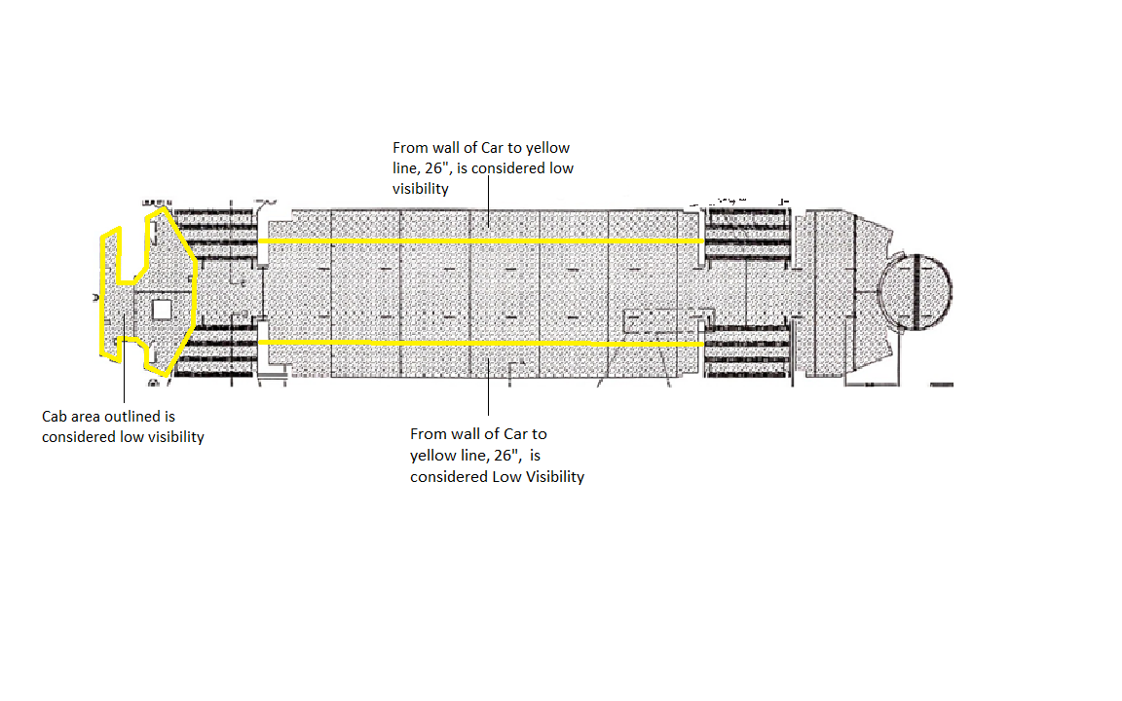

- Repairs

4.1 Blister Repair
- While installing the Precidium™ Transit Floor, blisters can occur. It is important that one understands the type of blister and what the cause is. After these two variables have been determined one must learn the proper repair technique. It is important to remember that there are different types of blisters and each type has different causes. For evaluation of each blister it must be cut open and examined carefully.

4.1.1Contaminated Substrate
- A contaminated substrate is the most common cause of blisters. Within this type of blister there are several causes. Note: These blisters almost always have a smooth finish on the bottom of the blister.

      - Moisture/Solvent Blistering: This is when moisture is on the surface of the substrate or in the substrate that is to be coated. The exothermic reaction of the Precidium™ Base Coat curing, heats the moisture/solvent. This rise in temperature causes expansion and off-gassing of moisture/solvent. This causes ballooning and pinholing of the coating as seen in Figure 1.

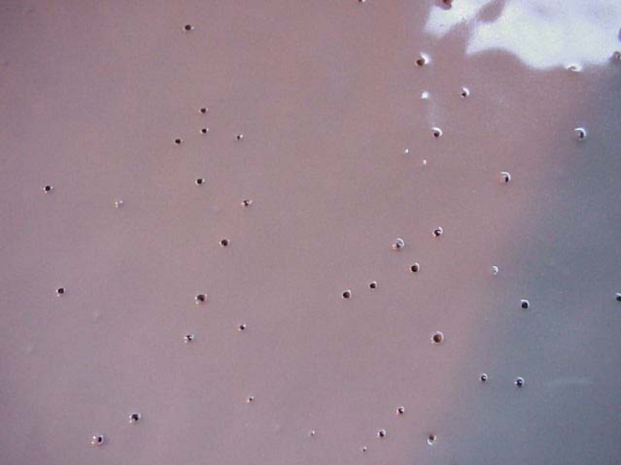
Figure 1 Ballooning and Pinholing

Solution: The repair for this issue is to sand down all balloon ridges and fill the void with Precidium™ MTI 2100. Be sure to work material in the voids with a hand trowel with multiple passes from multiple directions.

Prevention: Ensure substrate is allowed to dry for a minimum of 16 hours after it has been solvent wiped. Also ensure the applicator is not perspiring on the subfloor during application.
      - Rust, Dirt, Corrosion, etc.: This type of blistering is better described as delamination, but at first glance it can look like a blister. The basic mechanism seen is the elastomeric floor coating is applied to a separated substrate that is not the subfloor. This other substrate (rust, dirt, etc.) has very little too no adhesion to the surface. When the surface is heated by the exotherm of the coating being applied, the primer which could not adhere to the subfloor will delaminate. This can be caused by any substrate contamination. This type of blistering is the most preventable, by using good surface preparation techniques.

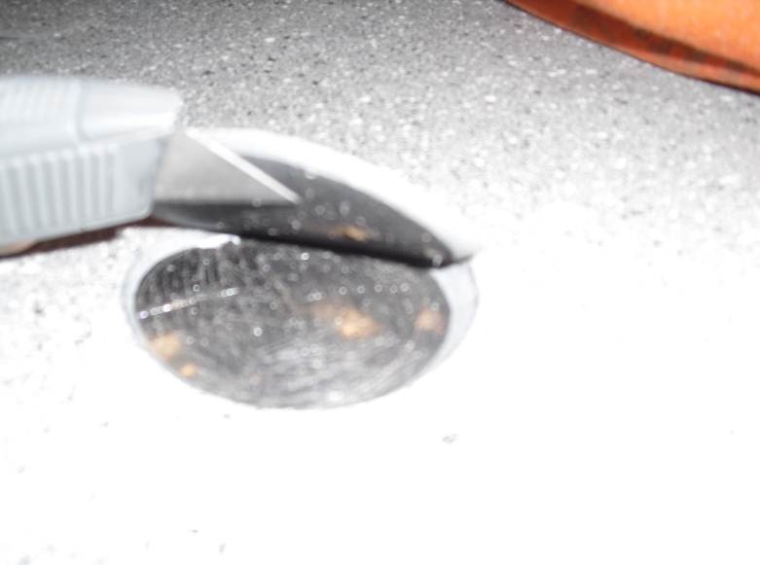

Figure 2: Delamination caused by Rust

Solution: Cut open the blister at the outer diameter. This cut should make a beveled edge. Clean out the containments, scuff and solvent wipe. Pour Precidium™ MTI 2100 into blister, close blister and hold down with a weight. Any excess Precidium™ MTI 2100 coming out of the seams can be wiped. After a minimum of 12 hours the weights can be removed. If this is done after the Precidium™ MTI Clear Top Coat, the Top Coat should be reapplied.

Prevention: This is easily prevented by always ensuring the surface is clean of all rust, dirt, residue and any other contamination.

      - MTI FR Membrane not applied in the Primer Coat’s recoat window. Two scenarios can occur, first, if the primer is recoated too soon or second, if the primer is recoated too late. When the primer is recoated too soon one common problem seen is the primer is tacky and traffic on the floor incorporates foreign contaminates which could cause an irregular surface profile. The primer must be recoated within 16 hours to achieve optimum adhesion. When this window has passed there is a greater chance for the floor to delaminate from the primer.

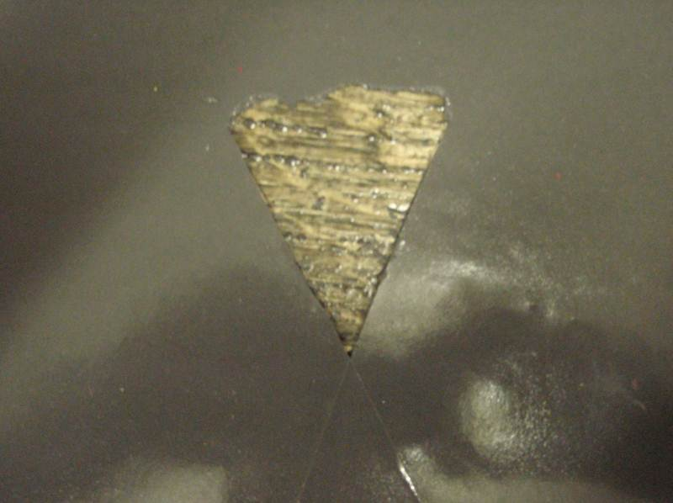
Figure 3 Delamination of Base Coat from Primer

Solution: Scuff and solvent wipe the primer. Mix and fill delaminated area with Precidium™ MTI 2100. If the primer was recoated after a long period of time (>48 hours) then general adhesion to the floor would be poor. Reapplication of the base coat might be the best solution however this will require the removal of the current membrane. Test the adhesion of the base coat to the floor using ASTM D4541-09, a minimum value for adhesion would be 500 psi.

Prevention: If the window for recoat has passed 16 hours the primed floor should be scuffed, and solvent wiped, after which the floor can be primed again.

    - ISO/Rich Blister
- These blisters are caused during application. Generally there will be a spike or drop in pressure on one component during application. A proficient applicator will feel this while spraying and can identify the area where this happened. When this pressure change occurs the material is mixed off ratio. When this happens a blister is formed.

- Resin Rich blisters will be gummy and wet underneath the blister. This material will always remain in a liquid/gel state.

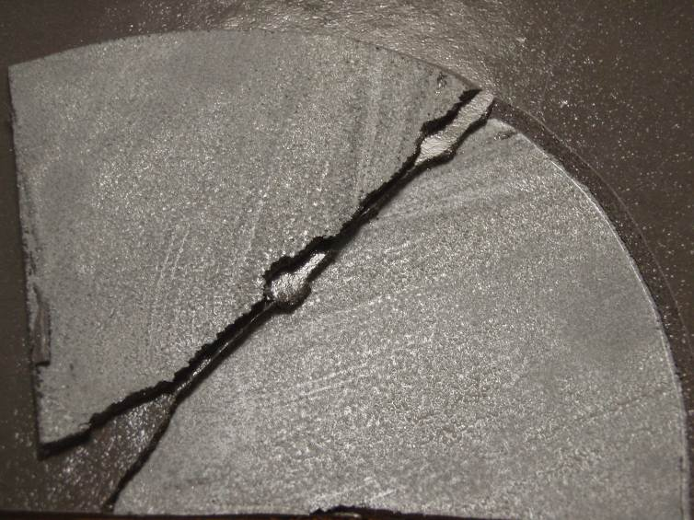
Figure 4 Resin Rich Blister, Wet and Gummy to touch

Solution: Cut out blister and dispose. Clean substrate by scuffing and solvent wiping. Then level off the blister with Precidium™ MTI 2100.

Prevention: Always ensure that the screens in the gun and equipment are cleaned. Ensure the mix module is drilled out regularly during application.

- ISO Rich Blisters will be rough and scaly. This material will eventually cure from moisture in the atmosphere and substrate.

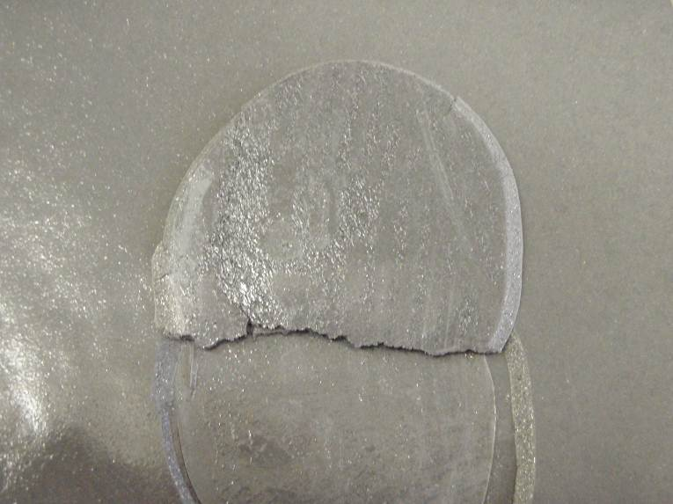
Figure 5 ISO Rich Blister, Rough and Scaly appearance

Solution: Cut out blister and dispose. Clean substrate by scuffing and solvent wiping, then level off the blister with Precidium™ MTI 2100. If it was only slightly off ratio it is possible the ISO has already cured. If this is the case the blister can be cleaned, scuffed and solvent wiped, after which Precidium™ MTI 2100 can be poured into the blister and held down with a weight until cured (min. 12 hours).

Prevention: Always ensure that the screens in the gun and equipment are cleaned. Ensure the mix module is drilled out regularly during application.

  - Surface Profile
- After the Precidium™ Base Coat is applied, the floor is thoroughly inspected for irregularities in the surface profile. This includes high/low ridges, any particles coated, voids, cracks, and shadows. This is more of an aesthetic finish.

    - High/Low Profile
A. Any areas that have any sprayed particles or high spots can be made flush with a rasp. This is done to the Precidium™ MTI FR Membrane, before the Precidium™ MTI PUD Accent Colors are applied.

B. Any low spots, voids, shadows should be leveled with Precidium™ MTI 2100. This is done with a plastic squeegee; any remaining ridges can be leveled with a rasp after the Precidium™ MTI 2100 has cured.
    - Particles, Shadows, Cracks, and Voids
- Any particles that were sprayed on the floor should be noticeable. These should be removed and repaired in between passes of the Precidium™ MTI FR Membrane.
- If improper spray technique is used when spraying cove bases around the seats a shadow can form. This will appear as a crack. This is preventable by spraying as close to 90 degrees from vertical surface as possible. This is repaired by cutting smooth with a utility knife and if necessary spraying more Precidium™ MTI FR Membrane.
- Any cracks and voids that are not prepared properly will be apparent after the floor is sprayed with the Precidium™ MTI FR Membrane.

  - Unwanted Termination Point
- If the wire trim tape shifted before the Precidium™ MTI FR Membrane is sprayed, the termination will vary from the desired point. This normally will be 0-1 inch inside the desired termination point. This is repaired with filling the spot with polyurethane caulking. After the caulk cures overnight the Precidium™ MTI Color TopCoat, PUD Color Accent , and MTI Clear Top Coat are reapplied. This is done without masking any defined lines, it is to be feathered in so no transition can be seen.

  - Post Installation Damage
  - Due to the work that still has to be done in the car, post installation damage can happen, and can be easily repaired. Fixing the damage is done using the above techniques followed by reapplying the Precidium™ MTI Color Topcoat, Precidium™ MTI PUD Accent Coats and Precidium™ MTI Clear Top Coat.

    - Chemical Damage
- During the first week of curing, the Precidium™ MTI Clear Top Coat is more susceptible to staining. If a chemical stain is found, the top can be scrubbed with a Scotch-Brite pad. Following removal of the stain, the Precidium™ MTI Clear Top Coat can be reapplied.

    - Physical Damage including full Recoat
Each instance of physical damage will have a specific repair.
- Large areas of damage or complete resurfacing, will be sanded and / or leveled with Precidium™ MTI 2100. Followed by the Precidium™ MTI Color Topcoat, PUD Color Accents, and Clear Top Coat re-applied as per the SOP.
- Medium areas of damage could possibly be just scuffed, solvent wiped, filled with Precidium™ MTI Color TopCoat. Depending on the size, they may also be sprayed with the Precidium™ PUD Color Accents, and Clear Top Coat.
- Small areas of damage can possibly just be filled with Precidium™ Clear Top Coat.
  - Quality Inspection Report 5: 4. Repairs

Date Started: _______________ Car Number: _______________
Date Completed: ____________ QA Officer: ________________

- Floor is inspected before application of Precidium™ MTI Color Top Coat? Yes No
- All repairs are completed before application of Precidium™ Color Top Coat? Yes No
- Finished floor has desired termination point? Yes No
- Precidium™ MTI PUD Color Accent Coats are acceptable? Yes No
- Floor is inspected after installation for damage? Yes No
- All repair work is finished after installation? Yes No
- Floor is inspected before shipping for post-installation damage? Yes No
- Any post-installation damage is repaired? Yes No

If any questions were answered ‘No’, please provide a detailed explanation.
______________________________________________________________________________________
______________________________________________________________________________________
______________________________________________________________________________________
______________________________________________________________________________________
______________________________________________________________________________________
______________________________________________________________________________________
*If any questions were answered ‘No’, approval from Quantum’s Project Manager is needed to continue*

______________________ ____________________
QA Officer *Project Manager*

- Safety_____________________________________________________

  - Personal Protective Equipment
- Pre-Spray Preparation; Standard Protective Equipment
- Floor Installation;
  - Implementation of Engineering Controls (i.e. Spray Booths and Local Exhaust Ventilation)
  - Training on MSDS’s
  - Respirators
    - Required: Full Face Supplied Fresh Air system, must have CO2 monitor system.
  - Eyes: Full face respirators
  - Body: Tyvek Suit, Boot Covers, Blue Nitrile Gloves,
  - Others: Fire extinguisher, eye wash station, drinking water, empty pails, spill mix, industrial paper towels.

  - Material Data Safety Data Sheets
-sent as a separate attachment

